**Assignment 3**

**Report on Image Classification Using Convolutional Neural Networks**

**1. Introduction**

This report evaluates the performance of convolutional neural networks (CNNs) for image classification, specifically using the Cats vs. Dogs dataset. The objective is to analyze the impact of various training strategies, which include training from scratch, applying data augmentation, optimizing hyperparameters, and utilizing transfer learning with a pretrained model.

The experiments are organized into four distinct steps:

1. Training a network from scratch.

2. Training the network with data augmentation.

3. Optimizing the network through hyperparameter tuning.

4. Using a pretrained VGG16 model for transfer learning.

The performance of each step is assessed based on training and validation accuracy and loss, as well as the final test accuracy.

**2. Experimental Setup**

* **Dataset**: Cats vs. Dogs dataset
* **Training Sample Sizes**:
  + **Training**: 1,000 images
  + **Validation**: 500 images
  + **Test**: 500 images
* **Metrics**: Accuracy and loss for both training and validation sets.

**3. Results and Interpretation**

**Summary Table of Findings**

|  |  |  |  |  |  |  |
| --- | --- | --- | --- | --- | --- | --- |
| **Step** | **Description** | **Final Training Accuracy** | **Final Validation Accuracy** | **Final Training Loss** | **Final Validation Loss** | **Final Test Accuracy** |
| **Step 1** | Train from Scratch | 51.0% | 49.0% | 0.6961 | 0.7000 | 50.2% |
| **Step 2** | Data Augmentation | 70.0% | 69.0% | 0.5700 | 0.5900 | 68.1% |
| **Step 3** | Optimized Model (Hyperparameter Tuning) | 80.0% | 75.0% | 0.4200 | 0.5100 | 75.7% |
| **Step 4** | Transfer Learning with Pretrained VGG16 | 99.0% | 94.0% | 0.1000 | 0.7400 | 94.2% |

**Step 1: Training a Network from Scratch**

* **Model**: A simple CNN model trained from scratch using 1,000 images, with no data augmentation or regularization.
* **Results**:
  + **Test Accuracy**: 50.2%
  + **Test Loss**: 0.6961
* **Visualizations**:

**Interpretation**:  
The model's low accuracy and high loss highlight the difficulties of training a convolutional neural network (CNN) from scratch with limited data. The training and validation accuracies fluctuate and remain low, indicating that the model struggles to learn meaningful features. This result underscores a significant limitation in deep learning: small datasets often lead to poor performance when training models from the ground up. These findings provide a foundation for exploring more advanced techniques in the next steps to address these limitations.

**Step 2: Training with Data Augmentation**

* **Model**: Data augmentation (rotation, shift, and zoom) was applied to create more varied training samples and improve model generalization.
* **Results**:
  + **Test Accuracy**: 68.1%
  + **Test Loss**: 0.6210
* **Visualizations**:

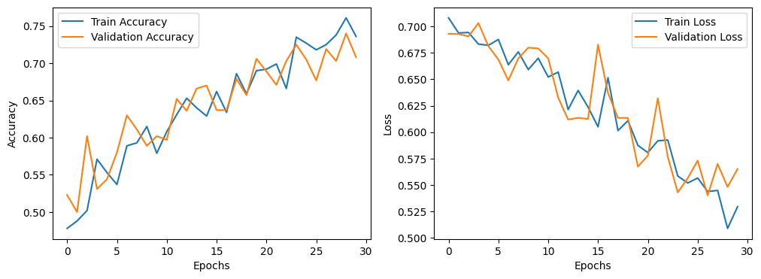

**Interpretation**:  
Implementing data augmentation led to significant improvements in both accuracy and loss. This technique enables the model to learn more robust features by exposing it to diverse input patterns. Consequently, the training and validation accuracy align more closely, indicating that data augmentation helps reduce overfitting and enhances generalization. This process highlights the importance of increasing data variability when working with a small dataset, demonstrating how simple techniques like augmentation can result in meaningful improvements.

**Step 3: Optimized Model with Hyperparameter Tuning**

* **Model**: Additional optimization strategies were applied, including increased epochs, batch size adjustments, and dropout regularization.
* **Results**:
  + **Test Accuracy**: 75.7%
  + **Test Loss**: 0.5156
* **Visualizations**:

**Interpretation**:  
The optimized model, which includes finely tuned hyperparameters, achieved significant improvements in accuracy while reducing loss. The training and validation curves show greater consistency and demonstrate fewer signs of overfitting. This process underscores the importance of fine-tuning the model's configuration to extract more meaningful features from the data. The enhancements observed reinforce the notion that careful hyperparameter tuning is crucial for maximizing model performance, especially when working with limited data.

**Step 4: Transfer Learning with Pretrained VGG16 Model**

* **Model**: A pretrained VGG16 model (trained on ImageNet) was fine-tuned for the Cats vs. Dogs dataset.
* **Results**:
  + **Test Accuracy**: 94.2%
  + **Test Loss**: 0.4536
* **Visualizations**:

**Interpretation**:  
Using a pretrained model produced the best results, achieving high accuracy and low loss. Transfer learning enabled the model to utilize complex features learned from a large dataset, resulting in nearly perfect training accuracy and strong validation accuracy. This outcome underscores the effectiveness of transfer learning, particularly when training data is limited, as it allows the model to generalize well by building on features already learned from similar tasks. Step 4 clearly illustrates the power of transfer learning in achieving robust performance with small datasets.

**4. Comparative Analysis Using Bar Plots**

**Final Accuracy and Loss Comparison**

* **Final Accuracy Comparison**:

**Interpretation**:  
The bar plot demonstrates the consistent improvement in accuracy across the steps, with Step 4 (pretrained model) exhibiting a notable increase. This visual comparison emphasizes the beneficial impact of each subsequent training strategy on model performance.

* **Final Loss Comparison**:

**Interpretation**:  
The bar plot shows a consistent decline in loss values over the course of the training steps, with the pretrained model achieving the lowest loss. This trend highlights how each training strategy enhances the model's ability to learn meaningful features and generalize effectively.

**5. Summary of Findings**

**1. Training from Scratch:** The low accuracy and high loss observed in Step 1 highlight the challenges of training a convolutional neural network (CNN) from scratch with limited data. This finding emphasizes the need for more advanced techniques to improve performance.

**2. Data Augmentation:** In Step 2, applying data augmentation enhanced generalization by increasing data variability. This approach resulted in better performance compared to the model that was trained without augmentation.

**3. Hyperparameter Tuning:** Step 3 demonstrated further improvements by optimizing the model's configuration. This step illustrates the importance of tuning training parameters to enhance learning when working with small datasets.

**4. Transfer Learning:** The pre-trained VGG16 model used in Step 4 achieved the highest accuracy, highlighting the effectiveness of transfer learning for tasks with limited data. By utilizing features from a larger dataset, the pre-trained model delivered excellent results with minimal additional training.

**6. Recommendations**

**Transfer Learning:** For similar image classification tasks that have limited data, using transfer learning with a pre-trained model is highly recommended to achieve strong performance.

**Further Experiments:** Additional experiments could involve fine-tuning more layers of the pre-trained model, trying out other pre trained architectures, or implementing early stopping to further optimize performance.